/usr/local/lib/python3.10/dist-packages/skimage/feature/__init__.py:35: skimage_deprecation: Function ``greycomatrix`` is deprecated and will be removed in version 1.0. Use ``skimage.feature.graycomatrix`` instead.

removed_version='1.0')

/usr/local/lib/python3.10/dist-packages/skimage/feature/__init__.py:42: skimage_deprecation: Function ``greycoprops`` is deprecated and will be removed in version 1.0. Use ``skimage.feature.graycoprops`` instead.

removed_version='1.0')

/usr/local/lib/python3.10/dist-packages/skimage/feature/__init__.py:42: skimage_deprecation: Function ``greycoprops`` is deprecated and will be removed in version 1.0. Use ``skimage.feature.graycoprops`` instead.

removed_version='1.0')

/usr/local/lib/python3.10/dist-packages/skimage/feature/__init__.py:42: skimage_deprecation: Function ``greycoprops`` is deprecated and will be removed in version 1.0. Use ``skimage.feature.graycoprops`` instead.

removed_version='1.0')

/usr/local/lib/python3.10/dist-packages/skimage/feature/__init__.py:42: skimage_deprecation: Function ``greycoprops`` is deprecated and will be removed in version 1.0. Use ``skimage.feature.graycoprops`` instead.

removed_version='1.0')

/usr/local/lib/python3.10/dist-packages/numpy/lib/npyio.py:518: VisibleDeprecationWarning: Creating an ndarray from ragged nested sequences (which is a list-or-tuple of lists-or-tuples-or ndarrays with different lengths or shapes) is deprecated. If you meant to do this, you must specify 'dtype=object' when creating the ndarray.

arr = np.asanyarray(arr)

Image: defect3.jpg

Pixel Intensity Statistics:

Mean Intensity: 0.29312499818918747

Standard Deviation: 0.1853748495340198

Geometric Features:

Number of Contours: 60

Texture Analysis:

Contrast: 145.54008884803923

Energy: 0.19817003133449326

Correlation: 0.9673125584735569

Homogeneity: 0.5428188348567851

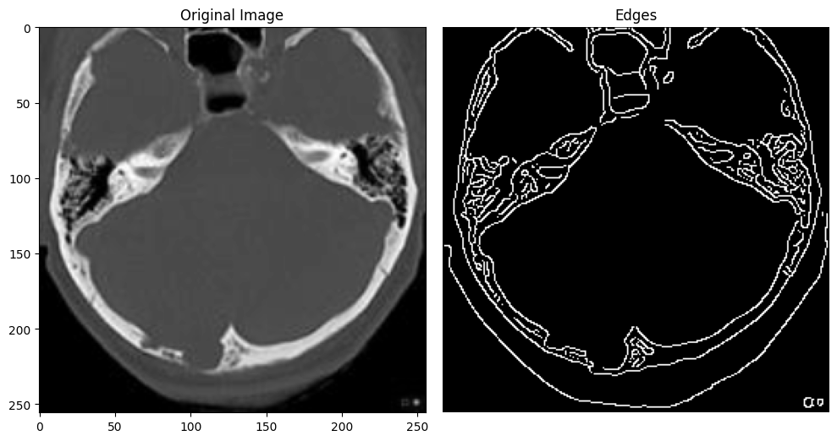

/usr/local/lib/python3.10/dist-packages/skimage/feature/__init__.py:35: skimage_deprecation: Function ``greycomatrix`` is deprecated and will be removed in version 1.0. Use ``skimage.feature.graycomatrix`` instead.

removed_version='1.0')

/usr/local/lib/python3.10/dist-packages/skimage/feature/__init__.py:42: skimage_deprecation: Function ``greycoprops`` is deprecated and will be removed in version 1.0. Use ``skimage.feature.graycoprops`` instead.

removed_version='1.0')

/usr/local/lib/python3.10/dist-packages/skimage/feature/__init__.py:42: skimage_deprecation: Function ``greycoprops`` is deprecated and will be removed in version 1.0. Use ``skimage.feature.graycoprops`` instead.

removed_version='1.0')

/usr/local/lib/python3.10/dist-packages/skimage/feature/__init__.py:42: skimage_deprecation: Function ``greycoprops`` is deprecated and will be removed in version 1.0. Use ``skimage.feature.graycoprops`` instead.

removed_version='1.0')

/usr/local/lib/python3.10/dist-packages/skimage/feature/__init__.py:42: skimage_deprecation: Function ``greycoprops`` is deprecated and will be removed in version 1.0. Use ``skimage.feature.graycoprops`` instead.

removed_version='1.0')

/usr/local/lib/python3.10/dist-packages/numpy/lib/npyio.py:518: VisibleDeprecationWarning: Creating an ndarray from ragged nested sequences (which is a list-or-tuple of lists-or-tuples-or ndarrays with different lengths or shapes) is deprecated. If you meant to do this, you must specify 'dtype=object' when creating the ndarray.

arr = np.asanyarray(arr)

Image: defect5.jpeg

Pixel Intensity Statistics:

Mean Intensity: 0.325243235372153

Standard Deviation: 0.23481047841967878

Geometric Features:

Number of Contours: 1

Texture Analysis:

Contrast: 29.63256740196078

Energy: 0.09395447904705358

Correlation: 0.9958454992131222

Homogeneity: 0.4827260276316604

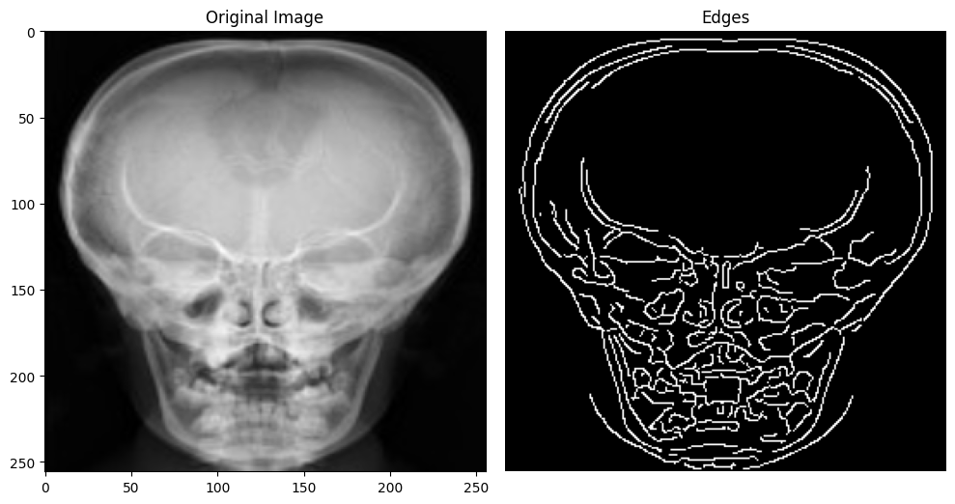

/usr/local/lib/python3.10/dist-packages/skimage/feature/__init__.py:35: skimage_deprecation: Function ``greycomatrix`` is deprecated and will be removed in version 1.0. Use ``skimage.feature.graycomatrix`` instead.

removed_version='1.0')

/usr/local/lib/python3.10/dist-packages/skimage/feature/__init__.py:42: skimage_deprecation: Function ``greycoprops`` is deprecated and will be removed in version 1.0. Use ``skimage.feature.graycoprops`` instead.

removed_version='1.0')

/usr/local/lib/python3.10/dist-packages/skimage/feature/__init__.py:42: skimage_deprecation: Function ``greycoprops`` is deprecated and will be removed in version 1.0. Use ``skimage.feature.graycoprops`` instead.

removed_version='1.0')

/usr/local/lib/python3.10/dist-packages/skimage/feature/__init__.py:42: skimage_deprecation: Function ``greycoprops`` is deprecated and will be removed in version 1.0. Use ``skimage.feature.graycoprops`` instead.

removed_version='1.0')

/usr/local/lib/python3.10/dist-packages/skimage/feature/__init__.py:42: skimage_deprecation: Function ``greycoprops`` is deprecated and will be removed in version 1.0. Use ``skimage.feature.graycoprops`` instead.

removed_version='1.0')

/usr/local/lib/python3.10/dist-packages/numpy/lib/npyio.py:518: VisibleDeprecationWarning: Creating an ndarray from ragged nested sequences (which is a list-or-tuple of lists-or-tuples-or ndarrays with different lengths or shapes) is deprecated. If you meant to do this, you must specify 'dtype=object' when creating the ndarray.

arr = np.asanyarray(arr)

Image: defect2.jpeg

Pixel Intensity Statistics:

Mean Intensity: 0.16604885377233375

Standard Deviation: 0.27899913307536356

Geometric Features:

Number of Contours: 38

Texture Analysis:

Contrast: 37.48258272058825

Energy: 0.6195222893543909

Correlation: 0.9962893336954758

Homogeneity: 0.7278697676923005

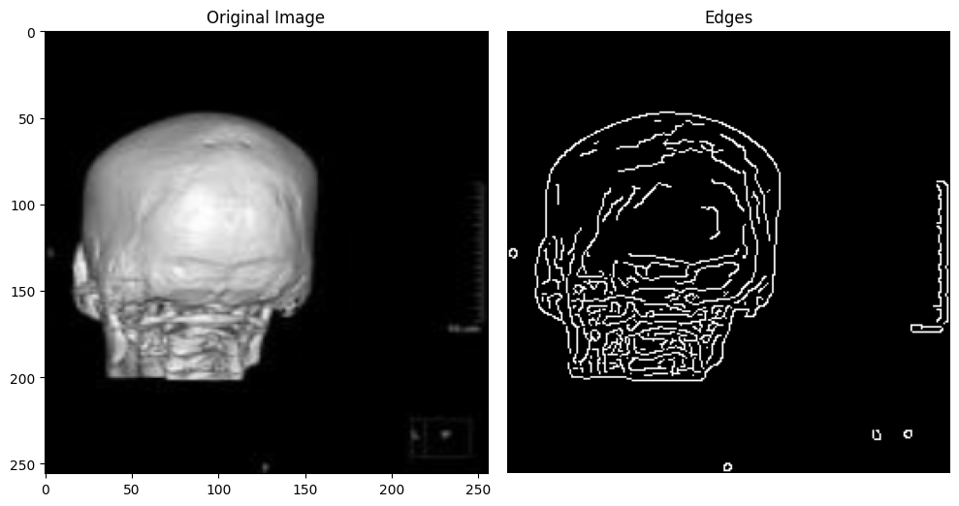

/usr/local/lib/python3.10/dist-packages/skimage/feature/__init__.py:35: skimage_deprecation: Function ``greycomatrix`` is deprecated and will be removed in version 1.0. Use ``skimage.feature.graycomatrix`` instead.

removed_version='1.0')

/usr/local/lib/python3.10/dist-packages/skimage/feature/__init__.py:42: skimage_deprecation: Function ``greycoprops`` is deprecated and will be removed in version 1.0. Use ``skimage.feature.graycoprops`` instead.

removed_version='1.0')

/usr/local/lib/python3.10/dist-packages/skimage/feature/__init__.py:42: skimage_deprecation: Function ``greycoprops`` is deprecated and will be removed in version 1.0. Use ``skimage.feature.graycoprops`` instead.

removed_version='1.0')

/usr/local/lib/python3.10/dist-packages/skimage/feature/__init__.py:42: skimage_deprecation: Function ``greycoprops`` is deprecated and will be removed in version 1.0. Use ``skimage.feature.graycoprops`` instead.

removed_version='1.0')

/usr/local/lib/python3.10/dist-packages/skimage/feature/__init__.py:42: skimage_deprecation: Function ``greycoprops`` is deprecated and will be removed in version 1.0. Use ``skimage.feature.graycoprops`` instead.

removed_version='1.0')

/usr/local/lib/python3.10/dist-packages/numpy/lib/npyio.py:518: VisibleDeprecationWarning: Creating an ndarray from ragged nested sequences (which is a list-or-tuple of lists-or-tuples-or ndarrays with different lengths or shapes) is deprecated. If you meant to do this, you must specify 'dtype=object' when creating the ndarray.

arr = np.asanyarray(arr)

Image: defect4.jpg

Pixel Intensity Statistics:

Mean Intensity: 0.2575518047692729

Standard Deviation: 0.2570363961582265

Geometric Features:

Number of Contours: 40

Texture Analysis:

Contrast: 155.84949448529412

Energy: 0.24996586984270144

Correlation: 0.9817984182887273

Homogeneity: 0.37967730396290394

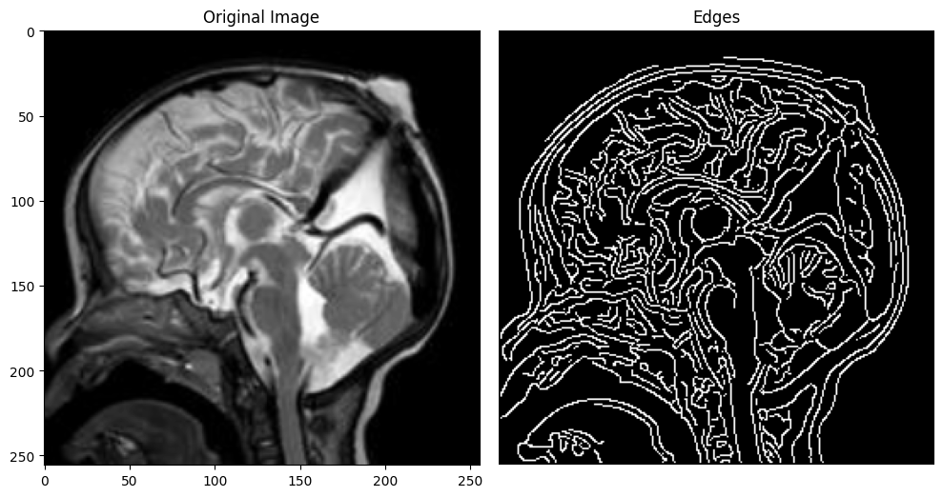

/usr/local/lib/python3.10/dist-packages/skimage/feature/__init__.py:35: skimage_deprecation: Function ``greycomatrix`` is deprecated and will be removed in version 1.0. Use ``skimage.feature.graycomatrix`` instead.

removed_version='1.0')

/usr/local/lib/python3.10/dist-packages/skimage/feature/__init__.py:42: skimage_deprecation: Function ``greycoprops`` is deprecated and will be removed in version 1.0. Use ``skimage.feature.graycoprops`` instead.

removed_version='1.0')

/usr/local/lib/python3.10/dist-packages/skimage/feature/__init__.py:42: skimage_deprecation: Function ``greycoprops`` is deprecated and will be removed in version 1.0. Use ``skimage.feature.graycoprops`` instead.

removed_version='1.0')

/usr/local/lib/python3.10/dist-packages/skimage/feature/__init__.py:42: skimage_deprecation: Function ``greycoprops`` is deprecated and will be removed in version 1.0. Use ``skimage.feature.graycoprops`` instead.

removed_version='1.0')

/usr/local/lib/python3.10/dist-packages/skimage/feature/__init__.py:42: skimage_deprecation: Function ``greycoprops`` is deprecated and will be removed in version 1.0. Use ``skimage.feature.graycoprops`` instead.

removed_version='1.0')

/usr/local/lib/python3.10/dist-packages/numpy/lib/npyio.py:518: VisibleDeprecationWarning: Creating an ndarray from ragged nested sequences (which is a list-or-tuple of lists-or-tuples-or ndarrays with different lengths or shapes) is deprecated. If you meant to do this, you must specify 'dtype=object' when creating the ndarray.

arr = np.asanyarray(arr)

Image: defect1.jpg

Pixel Intensity Statistics:

Mean Intensity: 0.20993694850440703

Standard Deviation: 0.269305110280345

Geometric Features:

Number of Contours: 34

Texture Analysis:

Contrast: 30.061795343137256

Energy: 0.4764270161393703

Correlation: 0.9968019413622642

Homogeneity: 0.6360309997427533

